***Feasibility Study Report***

**Replacing Digiclops SDK with FlyCapture SDK to Re-implement Digitizer**

**Author:** Dipti Killedar

**Instructor:** Dr. Frank Xu

**Gannon University**

**June 20, 2013**

**System Requirements**

* Hardware Requirements

Desktop with IEEE-1394 port (if laptop, another cable is required or there will be enough power)

Camera: Bumblebee 2 BB2-03S2M

1394 Cable

* Software Requirements

IDE: Visual Studio 2005 or 2008

FlyCapture v1.8 Release 27 (Windows 7, 64 bit version)

Triclops SDK v3.3 Beta 3 (Windows 7, 64 bit version)

(note: no need to install any version of Digiclops)

* Operating System: Windows 7 , 64 bit

Point cloud Viewer: to display point cloud

**Abstract**

Digiclops SDK has been replaced with Flycapture SDK and will not be supported in the near future. As current version of PRM’s Digitizer is implemented based on Digiclops/Triclops SDK, we need to rewrite the Digitizer software using Flycapture/Triclops SDK.

This report describes the results of the feasibility study of replacing Digiclops SDK with Flycapture SDK to re-implement Digitizer. It also provides a step-by-step guideline to install SDKs, obtain demo source code, configure compilation environments, and compile demo source code.

**Introduction**

Bumblebee2 3D camera is one of Stereo Vision series products produced by Point Grey Research, Inc. Since this series of camera products have multiple lenses, with the image processing software, these cameras can generate the 3D plotting graphs. There are two separate software need to be downloaded from the website of Point Grey Research, Inc. One is **FlyCapture v1.8 Release 27** which provides the driver and controlling system of the camera adjusting some settings such as brightness, resolution. The second one is **Triclops SDK v3.3 Beta 3** which provides an interface and some functions to generate the 3D point cloud files. Previously, the Triclops SDK is just a function library called by Digiclopsdemo in software Digiclops to achieve the 3D functions such as generating the 3D point cloud files. Now the new version of Triclops SDK absorbs all the features of software Digiclops containing both human interface and library of functions. The application which can generate the 3D point cloud files called Triclopsdemo.

**Software Installing and Compiling**

The downloading and installing process is the following:

* Open the website: <http://www.ptgrey.com/support/downloads/index.asp>

Here you need to register to get an account then sign in.

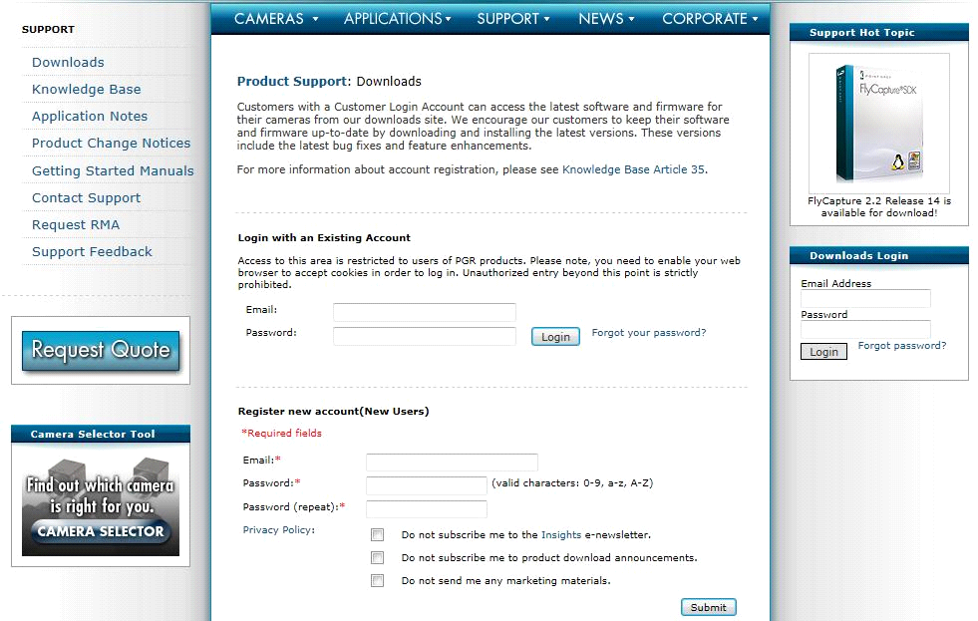

* Select appropriate Camera Family, Model number and Operating system.

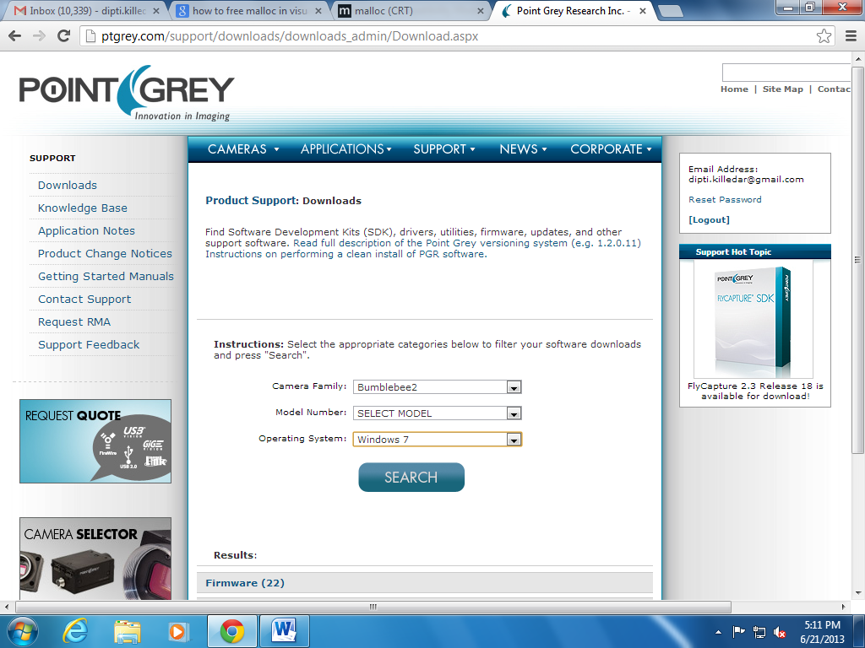

* It will give compatible versions of **FlyCapture and Triclops SDK.** Right nowFlyCapture v1.8 Release 27, Triclops SDK v3.3 Beta 3 isavailable**.** Download them.

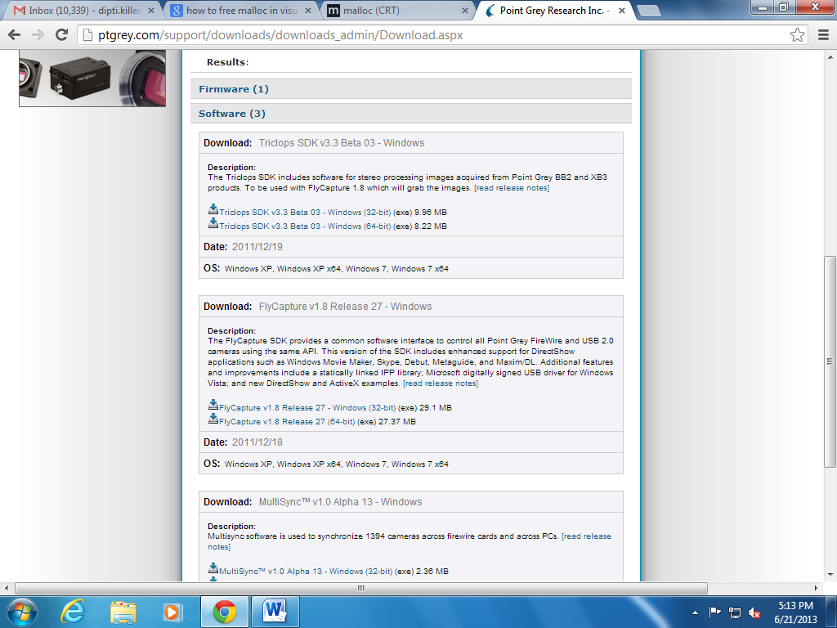

* **Installing the FlyCapture v1.8 :**
* Step 1:

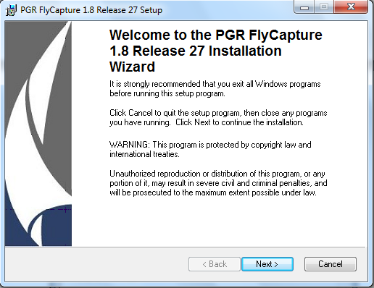

* Step 2:

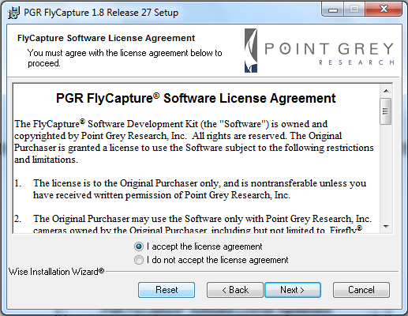

* Step 3:

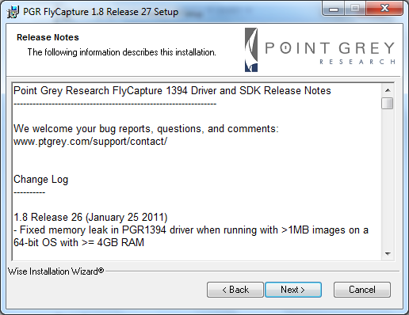

* Step 4:

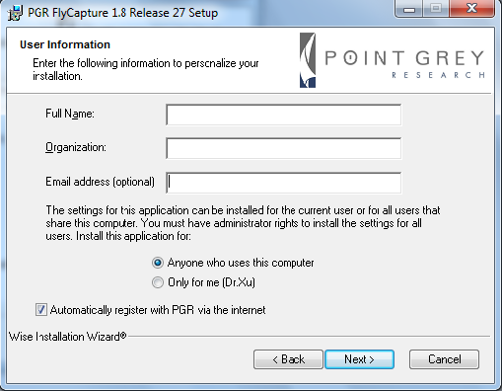

* Step 5:

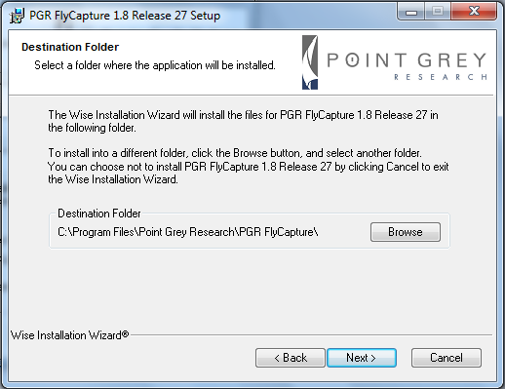

* Step 6:

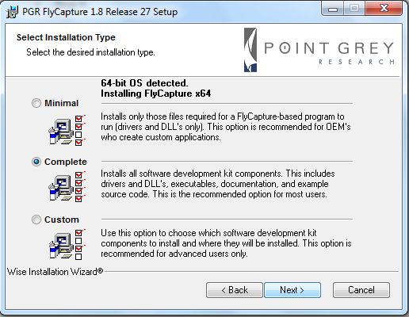

* Step 7:

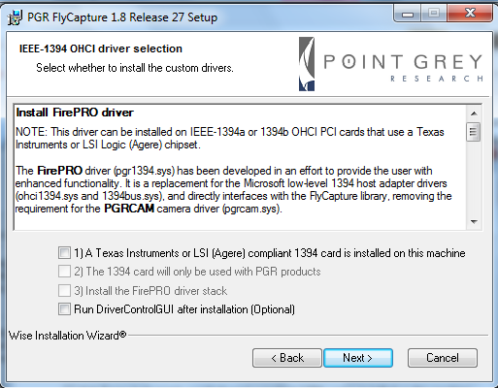

* Step 8:

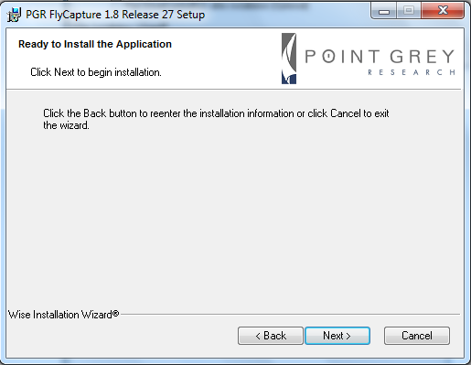

* Step 9:

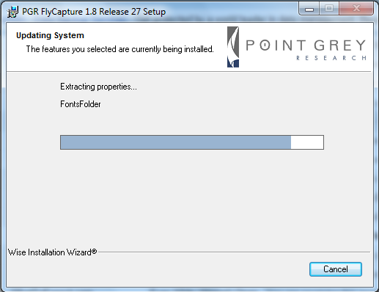

* Step 10:

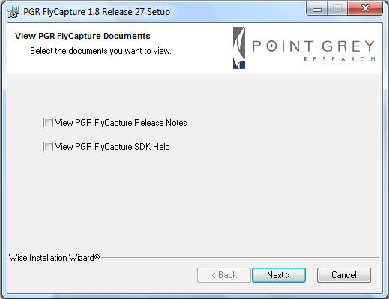

* Step 11:

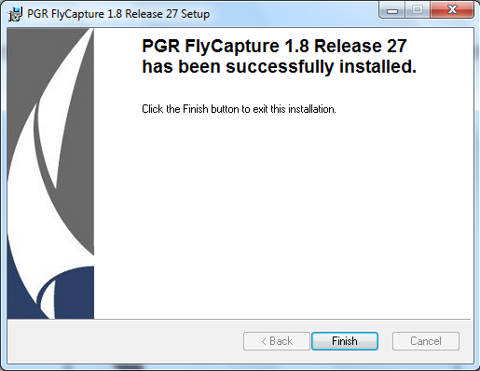

* **Installing the Triclops :**
* Step 1:

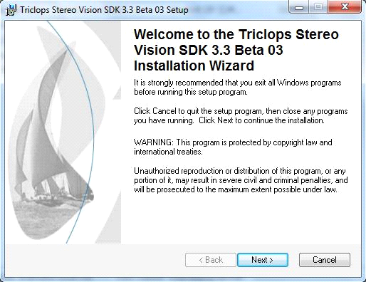

* Step 2:

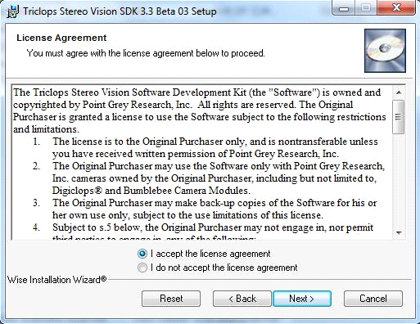

* Step 3:

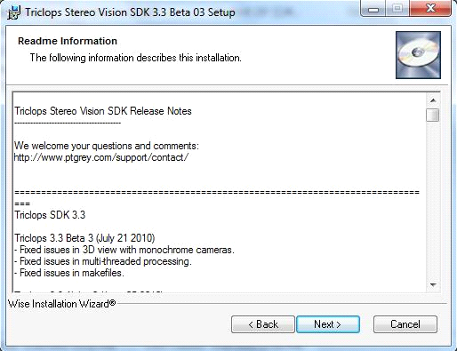

* Step 4:

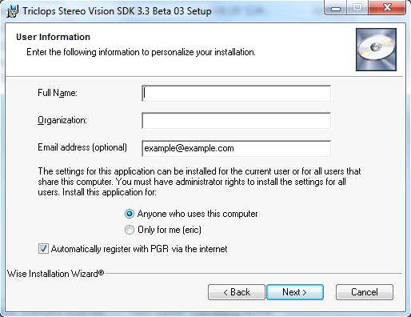

* Step 5:

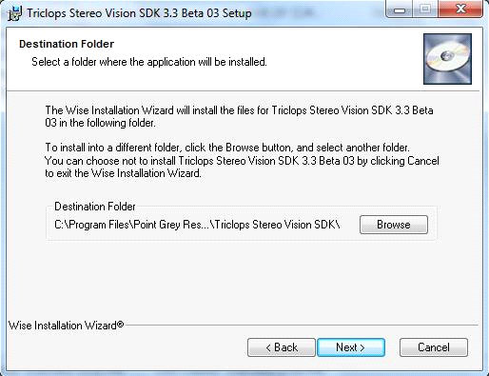

* Step 6:

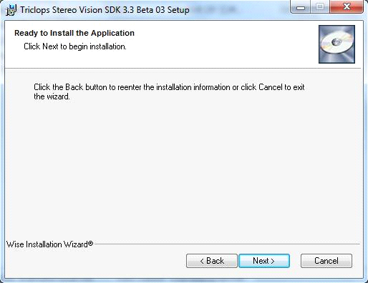

* Step 7:

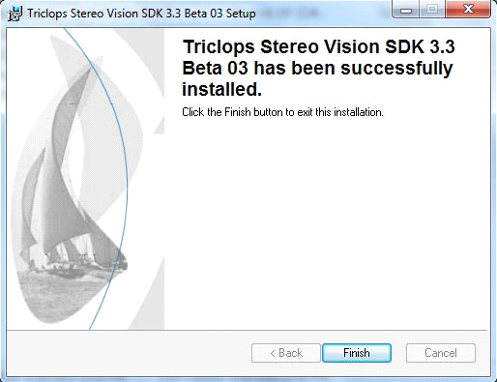

* **Using Case: Capturing a point cloud file**
* Open the Triclopsdemo application in the Triclops Stereo Vision SDK:

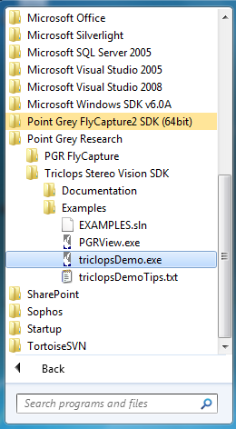

**NOTE :**

If you are using 64 bit machine, this step might give you an Application error.

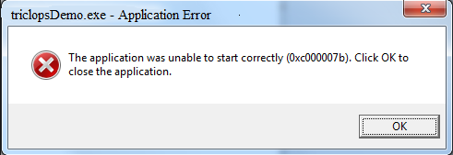

In this case you have to access triclopsDemo.exe from Program files. Follow the Path : C:\Program Files\Point Grey Research\Triclops Stereo Vision SDK\bin64\triclopsDemo.exe

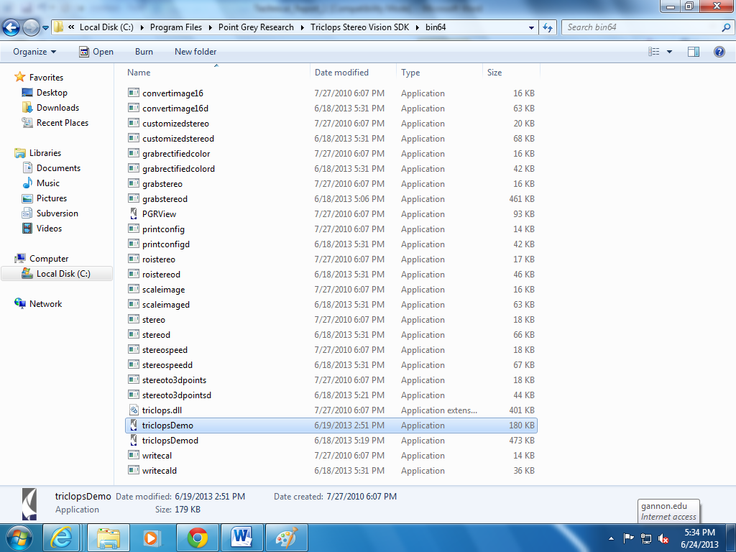

* Make sure camera is attached to the system. Select the Bumblebee 2 camea, press OK.

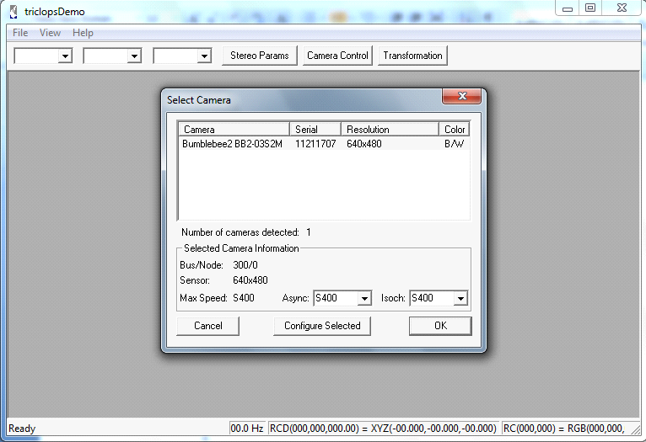

* Then you can see two images from two lenses of the Bumblebee 2 camera.

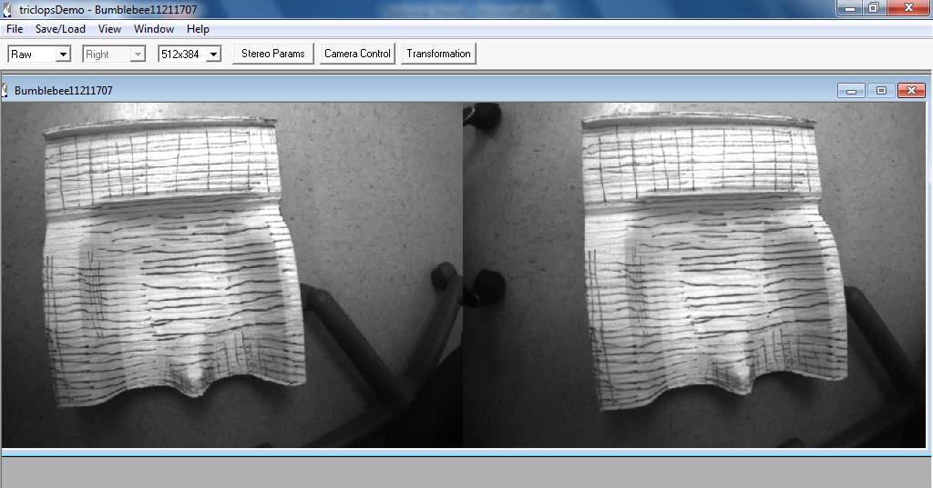

* Next select Window -> New 3d Window

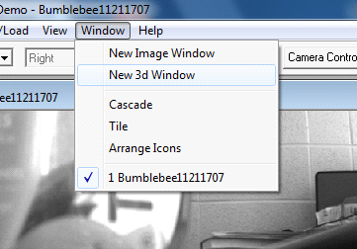

* Then you will see a new 3d window as following:

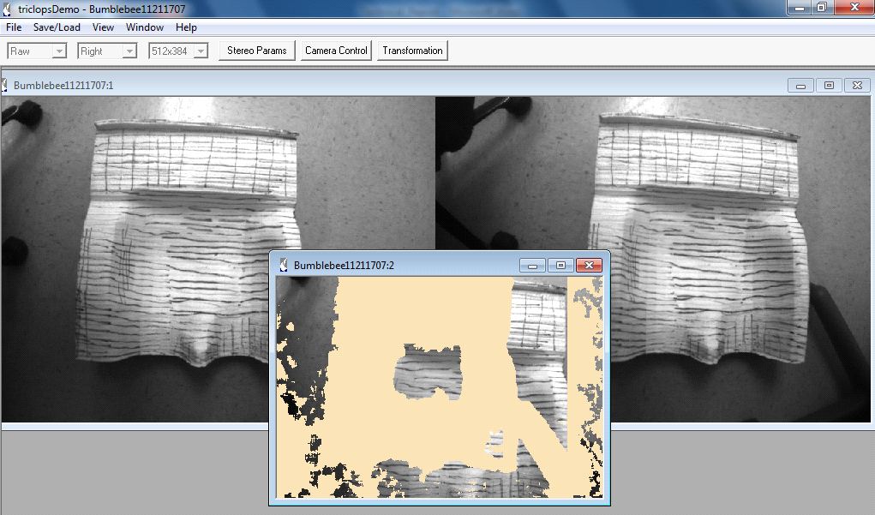

* Next Select Save/Load -> Save point cloud As

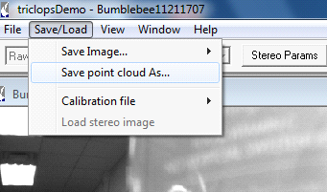

* Select the folder to save the file

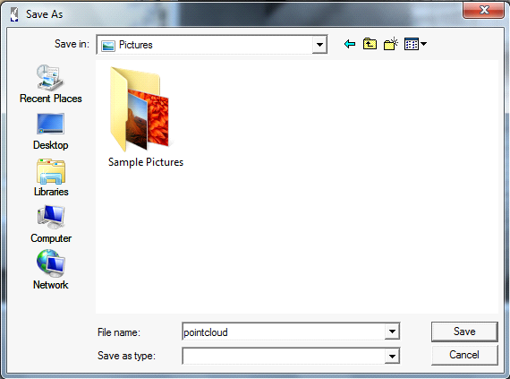

* Open the PGRview to browse the saved file:

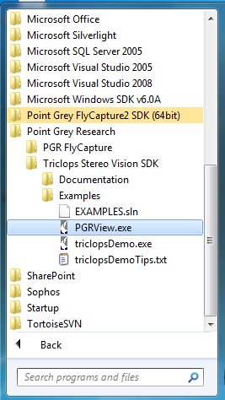

* File -> Open

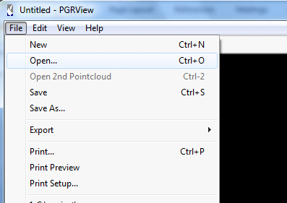

* Select the target saved file:

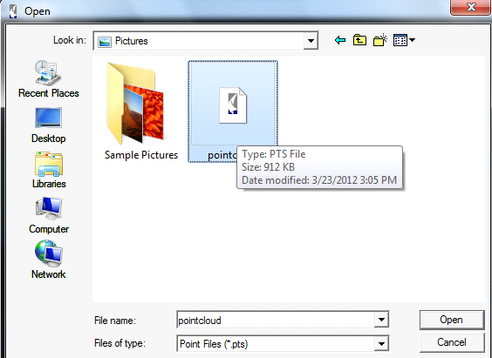

* Here is the point cloud file

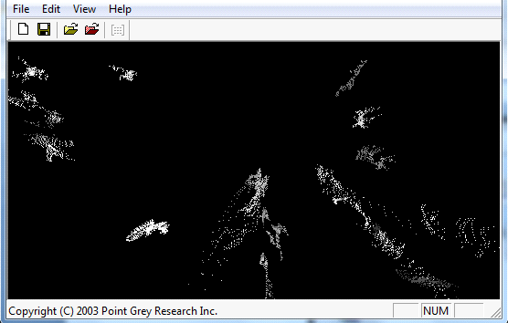

* **System Requirement for compiling the example source code**

The example source code can only be complied in Visual Studio 2005 environment. For other environment such as VS2008 or VS2010, the project need to be converted and may cause some unknown problem. Hence the VS2005 is highly recommended. Please do not use VS6.0 since the project will be no longer support the VS6.0 and lower editions. To compile the example code from the folder “src”, we need to adjust some environment settings in the Visual Studio 2005.

* Open the Visual Studio Solution file in the Visual Studio 2005, the specific path is Triclops Stereo Vision SDK\src\examples:

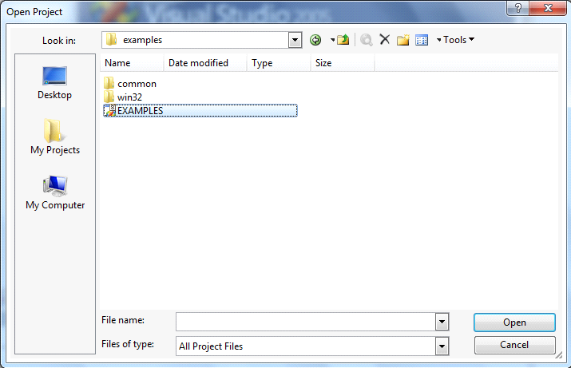

* Then the project will be opened as following:

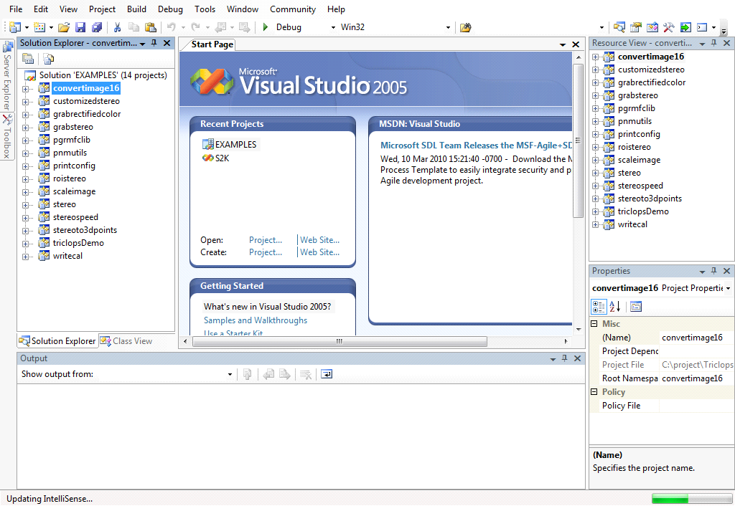

* Next is to set the startup project to be “triclopsdemo” since it is the main interface of the whole software. The process is following:

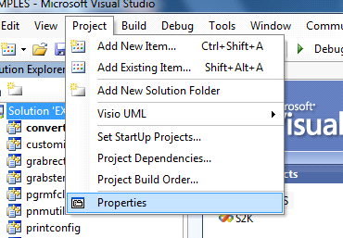

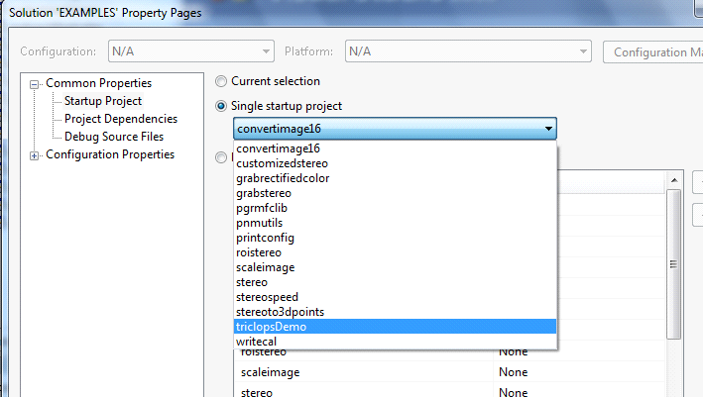

* After pressing Apply and OK to adjust the setting, press F5 to compile the whole project:

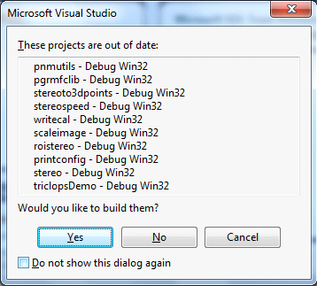

* After press Yes, the compilation will be finished.

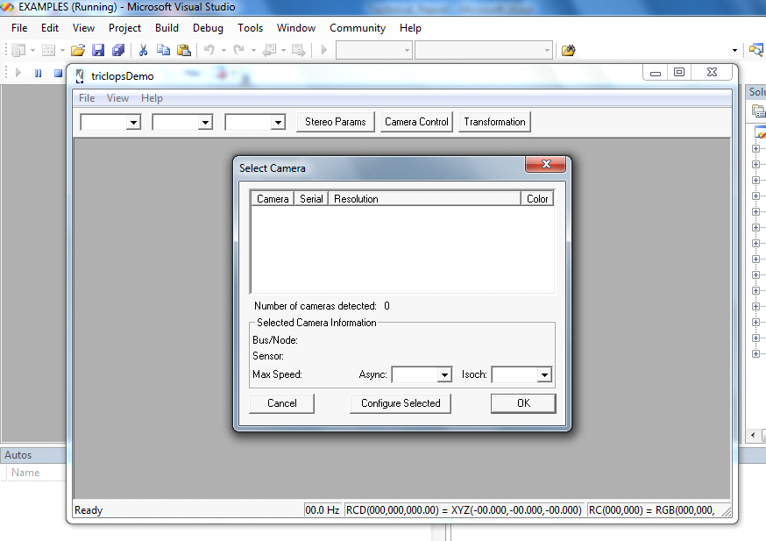

**NOTE:**

Application will also work in Visual Studio 2008. You need full version of VS 2008. Application will compile fine. It may give you some errors during runtime.

1. **It will probably give you error ‘Unable to start program’.**

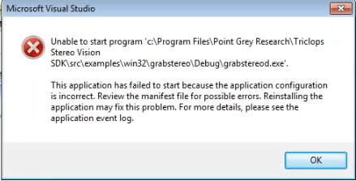

If it gives error and asks to reinstall application to fix the problem, go ahead and reinstall or repair VS 2008 as well as Triclops SDK.

If your program skipped debugging of your solution / project. Check for ‘amd64’ folder under this path (if you are using 64 bit machine, Solution configuration: debug and solution Platform: x64) -

C:\Program Files (x86)\Microsoft Visual Studio 9.0\VC\redist\amd64

If this folder is not there try repair or reinstall Visual studio 2008.

1. **If it gives Incremental Linker error.**

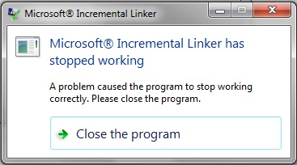

Install Microsoft Visual Studio 2008 Service pack 1. You can download this package from Microsoft’ site.

1. **If you get same error again check event log / event viewer. It may be because of side-by-side configuration error :**

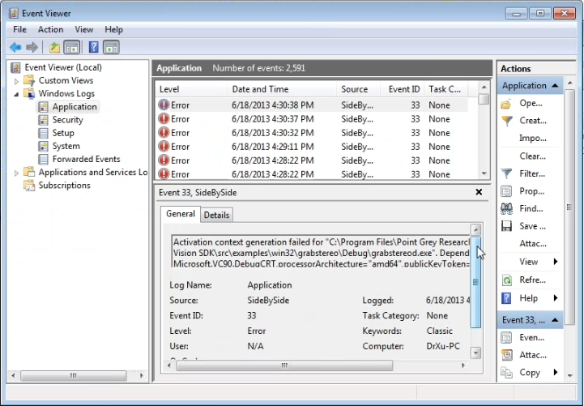

You need to install Microsoft Visual C++ 2005 redistributable package and Microsoft Visual C++ 2008 redistributable package for 64 bit machine if your machine is 64 bit.

Refer to the following tutorial :

[http://codeketchup.blogspot.c/2012/07/how-to-correct-side-by-side.html](http://codeketchup.blogspot.com/2012/07/how-to-correct-side-by-side.html)

Or follow the steps mentioned in ‘How to correct side-by-side configuration error try to run c++ application.pdf’ from the ‘Technical Report_Installation instruction’ folder.

1. **It may give you error when you try to debug program (64 bit).**

Helpful Link :

<http://social.msdn.microsoft.com/Forums/vstudio/en-US/b2aacd05-d9e9-4c6f-95f5-d6c005c9a5c6/not-getting-x64-debug-build-configurations-to-run-with-vc-2008>

Or read ‘Not getting _x64 Debug_ build configurations to run with VC++ 2008.pdf’ document from the ‘Technical Report_Installation instruction’ folder.

To make debug version run, you can either switch the Runtime library option from Multi-threaded debug DLL / MDd to Multi-threaded debug / MTd during compilation.

